

**Making Math SMART (K-5 Focus)**

**Saturday, February 15, 2014 | 11:10am-11:55am**

**UNCW Watson College of Education Room 232**

**Gretchen Robinson, Media Instructional Technology Facilitator   
(gretchen.robinson@onslow.k12.nc.us)**

**Michael Elder, Director-Academic Innovation   
(michael.elder@onslow.k12.nc.us)**

Academic Innovation

Math Jog the Web

|  |  |  |
| --- | --- | --- |
| WHAT | TIME | NOTES |
| Welcome and Opening Activity | 11:10 | (<http://www.jogtheweb.com/run/T8lSfT4yJVkV/Math-Tools-and-Resources>) |
| Overview of the Session | 11:12  Michael  Michael  Gretchen | Key Ideas:   * You, the teacher, are the most important resource * What kids can do with technology is more important that what the teacher can do * Focus is on Free (or Almost Free) Tools and Resources * Some resources are specific to SMART, but most are able to be used with or without a SMART Board   We will be using Jog the Web to store and share the resources from today.  We will discuss the SMART Exchange as a place where you can get even more ideas. |
| SMART Document Camera  *More than just a camera | 11:15  Gretchen | Ideas: Kids showing work and process  Kids’ pictures of their work  Saving kids’ work as a digital portfolio |
| Fraction Tools and a SMART Board | 11:25  Michael  Gretchen | Free tools shared on Jog the Web:  Featuring NCTM Illuminations;  Glencoe Virtual Tools- Fraction Bars;  National Library of Virtual Manipulatives- Fraction Addition  Smart Exchange for Fractions |

|  |  |  |
| --- | --- | --- |
| Compatible Tools | 11:40  Both | Other Online Tools (through the Jog the Web) Useful with SMART and Math Instruction |
| Flipping Out | 11:45  Gretchen | Using the Screen Recorder with SMART to:   * Flip Instruction * Allow students to record their process * Allow students to teach students   Merging with existing resources: Learn Zillion; Colleagues; School Tube; You Tube, etc. |
| SMART Notebook Math Tools | 11:53  Gretchen | Not free, but good resources  <http://smarttech.com/notebookmath> |

<http://downloads01.smarttech.com/media/sitecore/en/support/product/smartnotebookmath/2010/guides/guidesmartmathwindowsv10dec09.pdf>

Media Instructional Technology Services

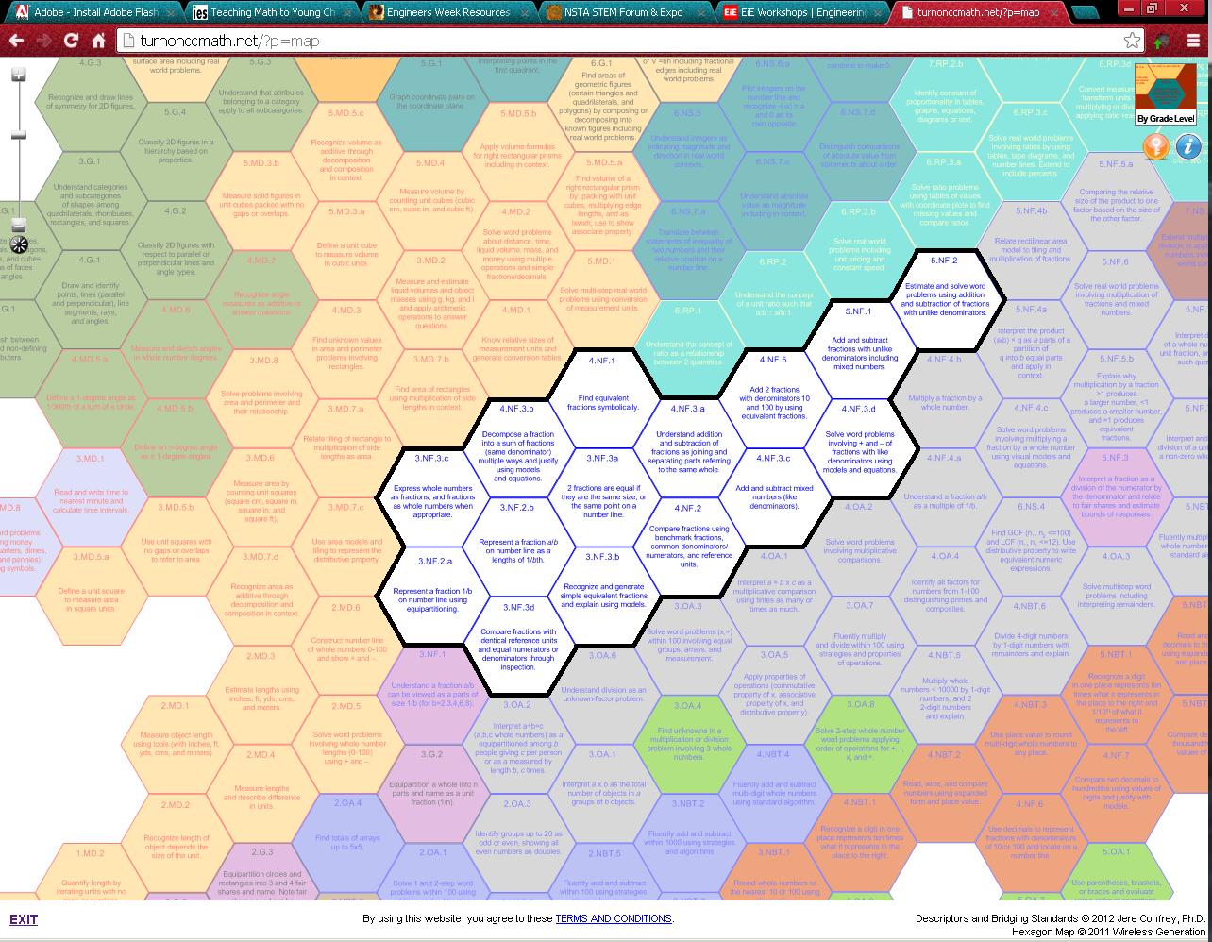

From

<http://turnonccmath.net/>

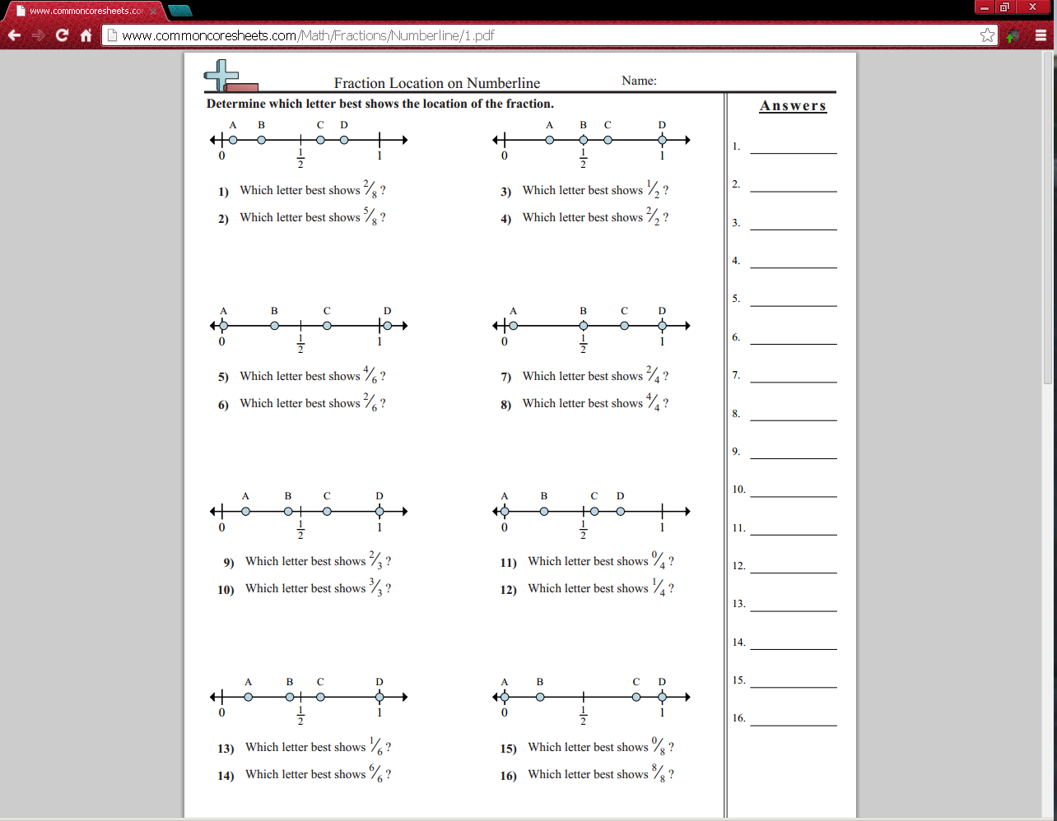 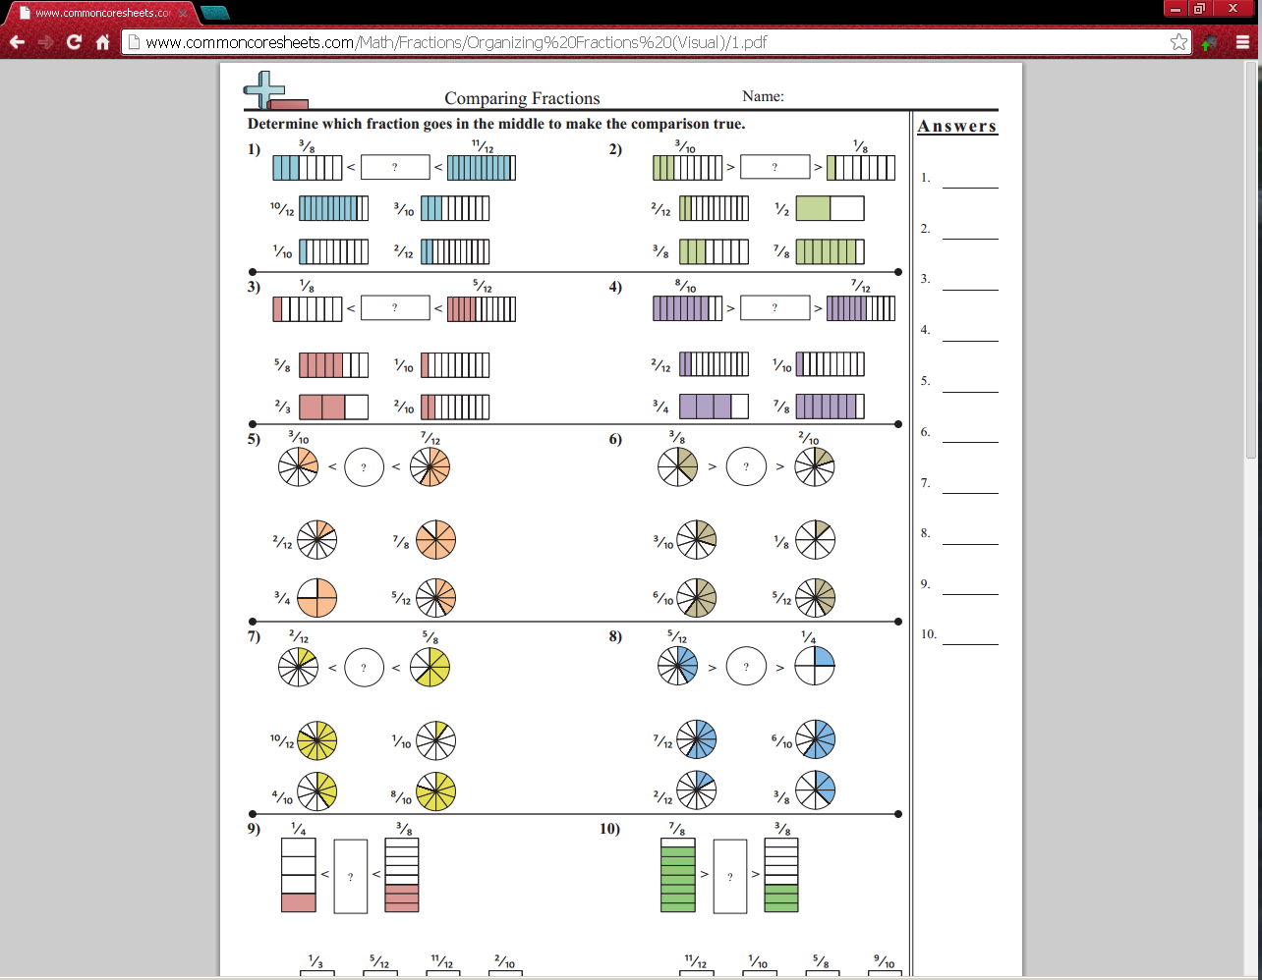

http://www.commoncoresheets.com/Math/Fractions/Organizing%20Fractions%20(Visual)/1.pdf

http://www.commoncoresheets.com/Math/Fractions/Numberline/1.pdf

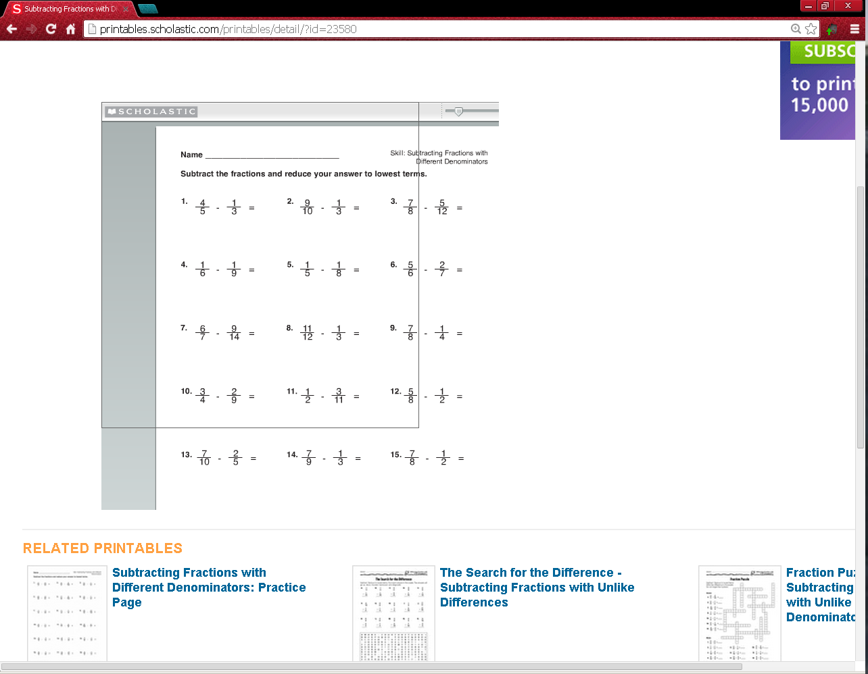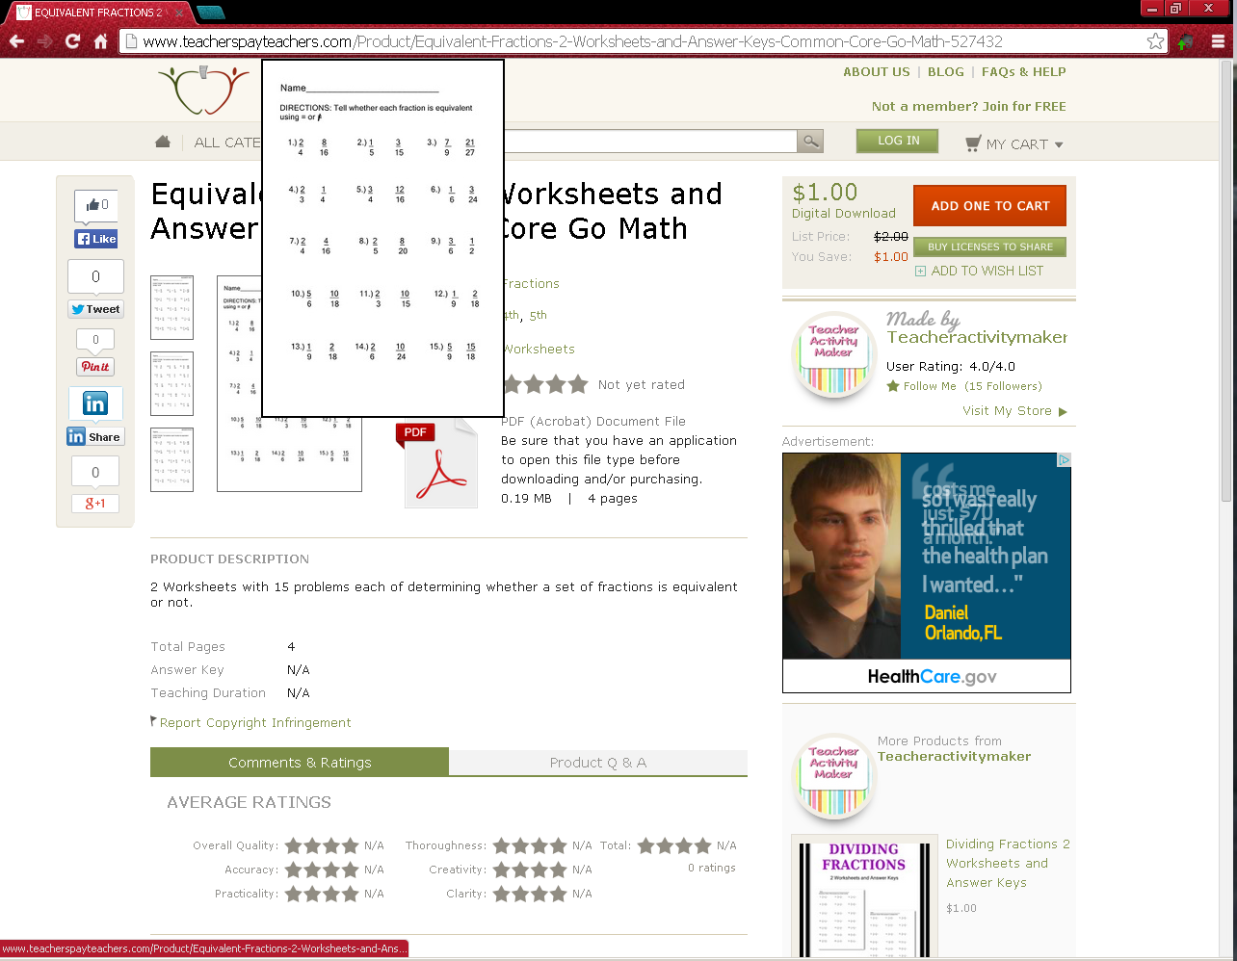

Please note that we are in no way endorsing these worksheets or these sites. They are simply what one might find when doing a search for Common Core Fraction Worksheet.

http://printables.scholastic.com/printables/detail/?id=23580

http://www.teacherspayteachers.com/Product/Equivalent-Fractions-2-Worksheets-and-Answer-Keys-Common-Core-Go-Math-527432

***Why Fractions?***

Third Grade

* “Develop understanding of fractions as numbers.”

2. Students develop an understanding of fractions, beginning with unit fractions. Students view fractions in general as being built out of unit fractions, and they use fractions along with visual fraction models to represent parts of a whole. Students understand that the size of a fractional part is relative to the size of the whole. For example, 1/2 of the paint in a small bucket could be less paint than 1/3 of the paint in a larger bucket, but 1/3 of a ribbon is longer than 1/5 of the same ribbon because when the ribbon is divided into 3 equal parts, the parts are longer than when the ribbon is divided into 5 equal parts. Students are able to use fractions to represent numbers equal to, less than, and greater than one. They solve problems that involve comparing fractions by using visual fraction models and strategies based on noticing equal numerators or denominators.

Fourth Grade

* Extend understanding of fraction equivalence and ordering.
* Build fractions from unit fractions by applying and extending previous understandings of operations on whole numbers.
* Understand decimal notation for fractions, and compare decimal fractions.

2. Students develop understanding of fraction equivalence and operations with fractions. They recognize that two different fractions can be equal (e.g., 15/9 = 5/3), and they develop methods for generating and recognizing equivalent fractions. Students extend previous understandings about how fractions are built from unit fractions, composing fractions from unit fractions, decomposing fractions into unit fractions, and using the meaning of fractions and the meaning of multiplication to multiply a fraction by a whole number.

Fifth Grade:

* Use equivalent fractions as a strategy to add and subtract fractions.
* Apply and extend previous understandings of multiplication and division to multiply and divide fractions.

1. Students apply their understanding of fractions and fraction models to represent the addition and subtraction of fractions with unlike denominators as equivalent calculations with like denominators. They develop fluency in calculating sums and differences of fractions, and make reasonable estimates of them. Students also use the meaning of fractions, of multiplication and division, and the relationship between multiplication and division to understand and explain why the procedures for multiplying and dividing fractions make sense. (Note: this is limited to the case of dividing unit fractions by whole numbers and whole numbers by unit fractions.)